**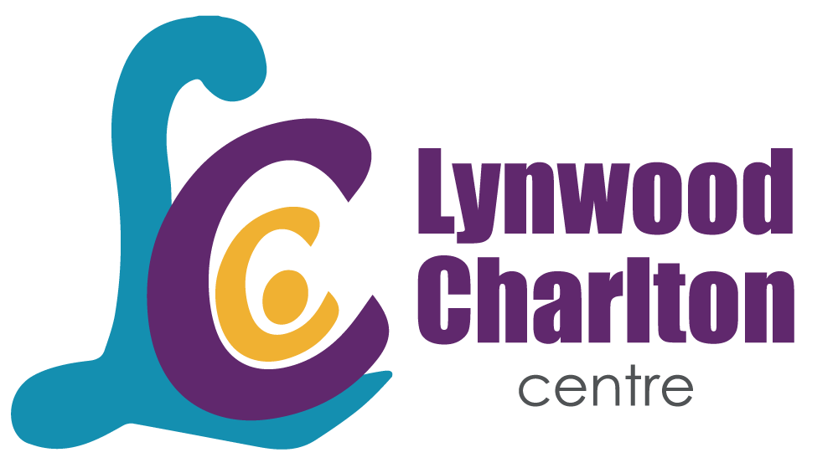****

**Media release**

**Smilezone Foundation and Toronto Rock Unveil Vibrant Spaces for Joyful Healing at Lynwood Charlton Centre**

**Hamilton, ON** – May 1, 2024 *–* Children attending Lynwood Charlton Centre’s day treatment program have been given a new reason to smile. On Wednesday, May 1, Lynwood Charlton officially opened three new Smilezone spaces in the day treatment program at the Upper Paradise site in Hamilton, Ontario. Generously donated by Smilezone Foundation, with support from the Toronto Rock, Hamilton’s professional box lacrosse team. The bright, fun Smilezones include murals, sensory development equipment, whiteboards, and lacrosse equipment for the gymnasium meant to help improve the experience for children and families while engaging in day treatment.

“The Toronto Rock and Smilezone have made our spaces so warm and welcoming. These Smilezones could not come at a more perfect time, as we support children to improve their mental health and achieve wellness. We are so grateful to the Toronto Rock and the Smilezone Foundation for such an impactful gift,” said Michelle Hayes, Senior Director of Program Operations and System Planning. “Our staff are passionate about delivering high-quality mental health care and now the physical environment will provide the rich conditions that promote well-being”.

Smilezone transformed the gymnasium, art room and sensory room in the day treatment area of LCC’s Upper Paradise location. Children will now be greeted with a lacrosse-themed gymnasium, and beautiful art-themed murals in the art room while soft and calming colours adorn the sensory room to provide a relaxing space for children.

"We couldn't be more ecstatic to be a part of this incredible renovation at Lynwood Charlton Centre," said Scott Bachly, Smilezone Foundation Chair. "These new Smilezones are more than just spaces; they're beacons of joy for children and their families, providing them with reasons to smile throughout their treatment journey. A massive thank-you goes out to the Toronto Rock, whose unwavering support we gratefully acknowledge today."

Smilezone Foundation believes in creating happy, positive spaces for healing. Smilezones transform clinical settings like hospitals, rehab centers, mental health clinics, autism treatment centers, and Children’s Aid Societies into warm, inviting spaces where children can freely express themselves, unwind, and receive support in a secure environment.

“We are extremely proud of our partnership with Smilezone Foundation,” said Toronto Rock Owner, President, and GM Jamie Dawick. “Working together on another Hamilton-based project is exciting for us.  Hamilton is our home, and we want to use our platform in any way we can to help make a positive impact in the community.  I want to thank our fans, players, and staff for supporting our annual fundraising efforts, making this Smilezone transformation possible!”

For information on ways to support community health care and to see photos of the new Smilezone, visit [www.lynwoodcharlton.ca](http://www.oslerfoundation.org).

-30-

**ABOUT LYNWOOD CHARLTON CENTRE**:

Lynwood Charlton Centre is a publicly funded charitable organization in the City of Hamilton. We provide a spectrum of innovative and evidence-informed, mental health services. These include residential, day treatment, and school, home, and community-based services for children, youth and their families. The Centre is funded and licensed by the Ministry for Children and Youth Services and accredited by the Canadian Centre for Accreditation.

**ABOUT SMILEZONE FOUNDATION:**

Smilezone Foundation is a registered charity committed to improving the lives of children receiving medical treatment at health facilities across Canada. Established in Oakville, Ontario in 2012 when founders Adam Graves and Scott Bachly were approached to make a financial contribution to the construction of a local hospital. Through partnerships with hospitals, community centers, and other organizations, Smilezone creates accessible, fun, and therapeutic environments where children can heal and thrive. Smilezone has transformed over 395 spaces into Smilezones across Canada, benefiting over 83 communities and reaching more than 340,000 children annually. For more information, visit [www.smilezone.com](http://www.smilezone.com/).

**For more information:**

Micki Benedetti Michelle Hayes

Smilezone Foundation Senior Director, Program Operations and System Planning

P: 905-466-2575 Lynwood Charlton Centre

benedetti.micki@gmail.com P: 905-389-1361

mhayes@lynwoodcharlton.ca